Network Topology Design, Configuration and Connectivity Verification
  - TechBiz Academy | CCNA Internship | Week 1 – Task 1
Lab environment: Cisco Packet Tracer
Topology: 2 Routers, 2 Switches, 4 PCs
Routing method: Static IPv4 Routing
Practical result: Successful communication between all four PCs
Supporting evidence: CCNA Week 1 Task 1 — Notion Lab Documentation
Packet Tracker lab

Objectives
The objective of this lab was to build and configure a functional network using Cisco Packet Tracer and understand how network devices communicate.
The practical Activities included:
- Building network with 2 routers, 2 Switch, and 4 PCs.
- Configuring IPv4 address on the PCs, router interface.
- Establishing routes between the networks.
- Testing communication with ping.
- Tracing the ping path from PC A to PC D.
- Understand the roles of the devices in the network.

Network Topology
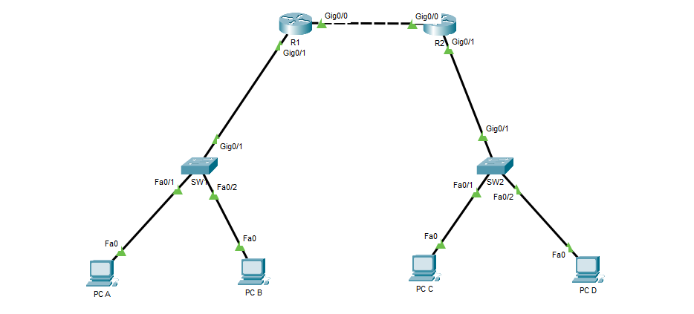
Figure 1: Network Diagram
The topology consists of 2 LANs 192.168.10.0 on SW1 with PC A and PC B connected to it. 192.168.20.0 network on SW2 with PC C and PC D connected to it.
The connection between R1 and R2 is 10.0.0.0/30 network.

IP addressing
Device | Interface | IP Address | Subnet Mask
R1 | G0/1 | 192.168.10.1 | 255.255.255.0
R1 | G0/0 | 10.0.0.01 | 255.255.255.252
R2 | G0/0 | 10.0.0.2 | 255.255.255.252
R2 | G0/1 | 192.168.20.1 | 255.255.255.0
PC A | Fa0 | 192.168.10.10 | 255.255.255.0
PC B | Fa0 | 192.168.10.11 | 255.255.255.0
PC C | Fa0 | 192.168.20.10 | 255.255.255.0
PC D | Fa0 | 192.168.20.11 | 255.255.255.0

Router Configurations
R1
Router interface G0/1 was assigned IP address of 192.168.10.1 255.255.255.0 and enabled with no shutdown command. Interface G0/0 was assigned IP address of 10.0.0.1 255.255.255.252 and enabled with no shutdown.
And, static route to 192.168.20.0 network via 10.0.0.2 was configured.
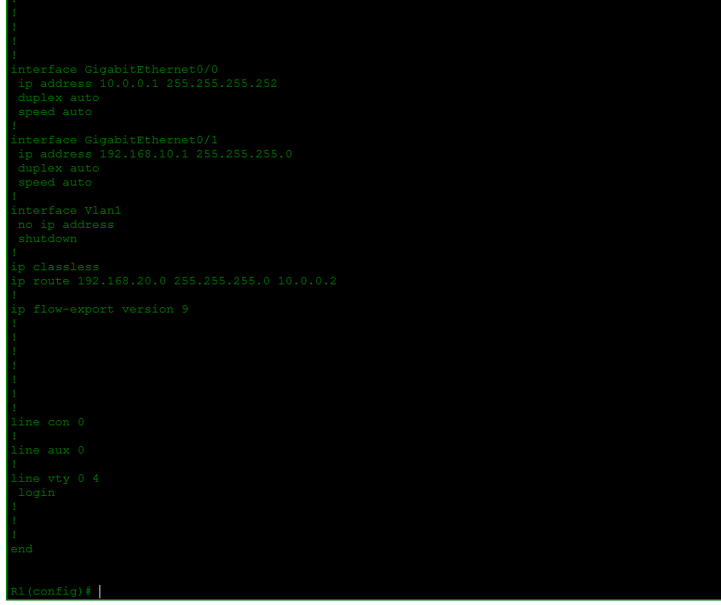
R2
Router interface G0/1 was assigned IP address of 192.168.20.1 255.255.255.0 and enabled with no shutdown command. Interface G0/0 was assigned IP address of 10.0.0.2 255.255.255.252 and enabled with no shutdown.
And, static route to 192.168.10.0 network via 10.0.0.1 was configured.
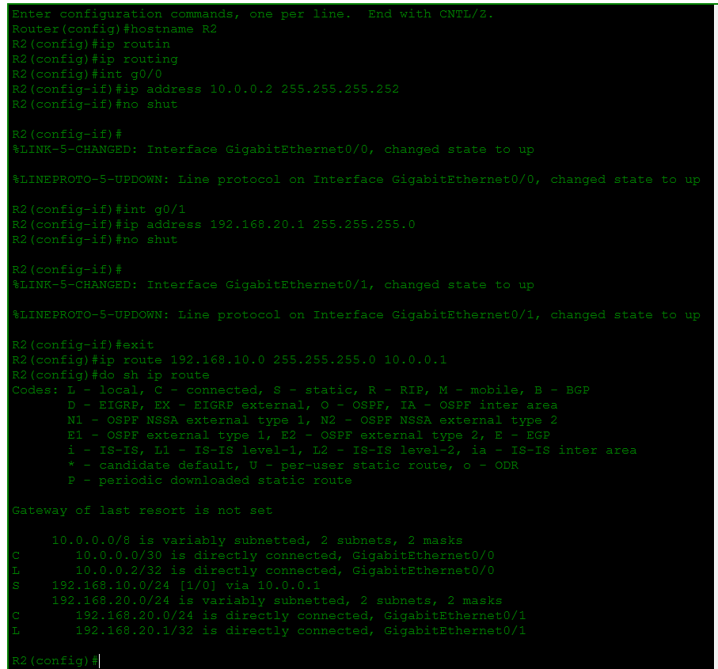
The show ip route command confirmed that each router had static route to the remote LAN.
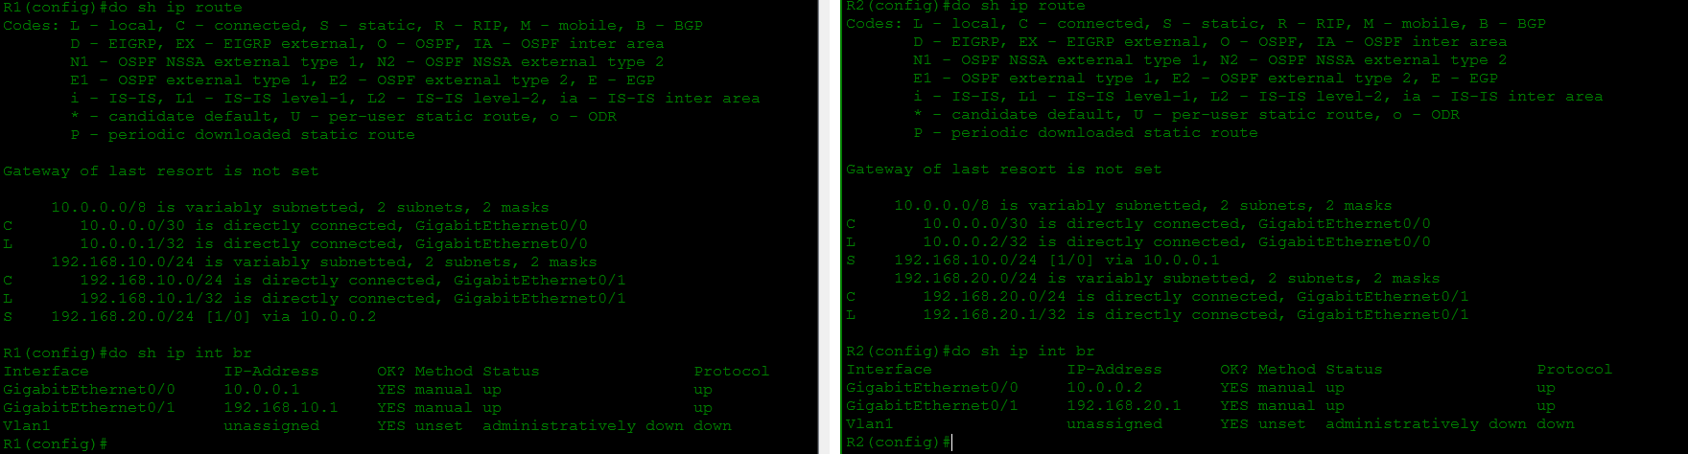

PC configurations
Assigned the PC’s with the respective IP addresses.
PC A
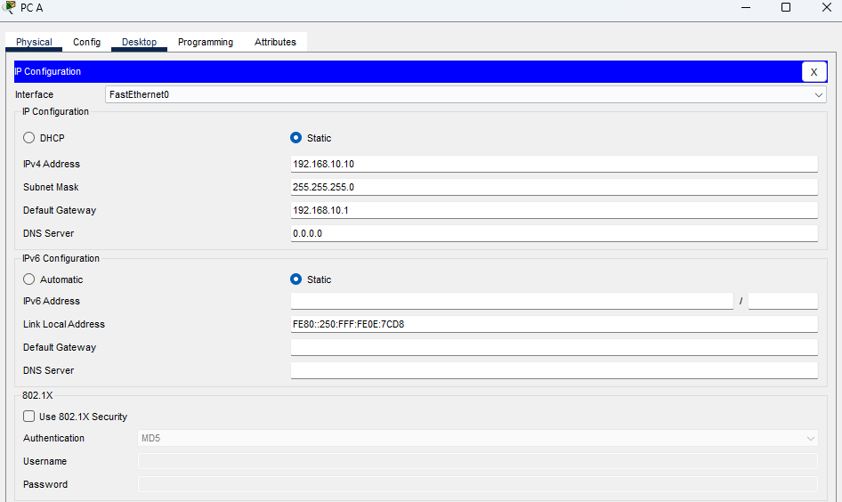
PC B
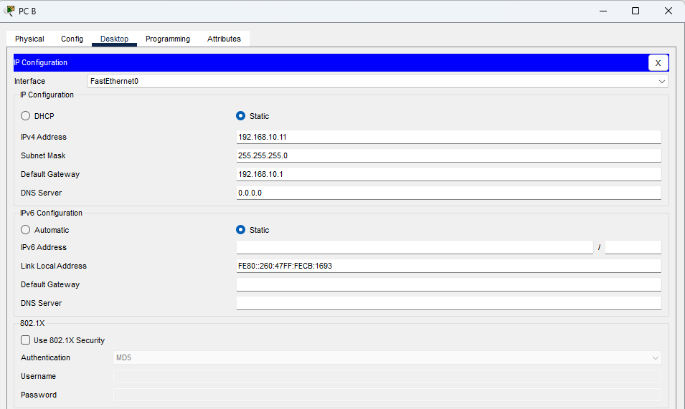

PC C
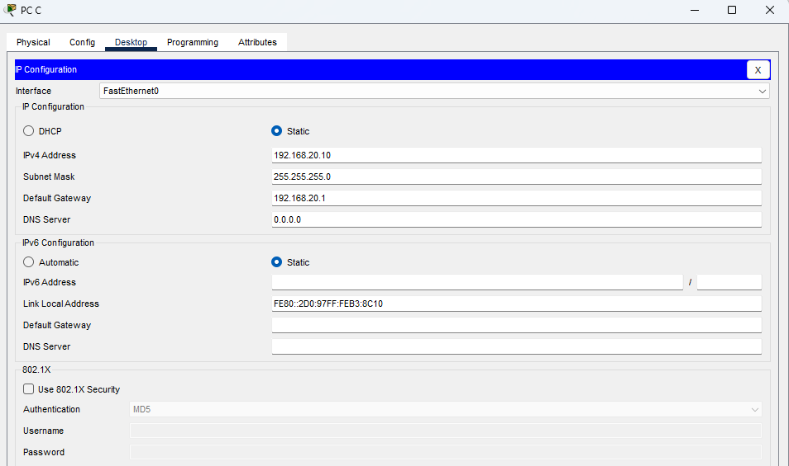
PC D
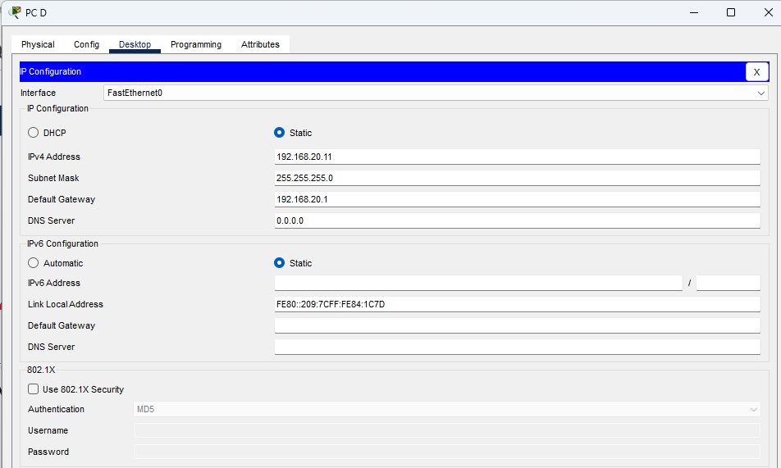

Testing connection
Pinged all end hosts from each of the end host that resulted in success. Total: 12 successful directed PC-to-PC tests, each with four replies received and 0% packet loss in the final successful runs.
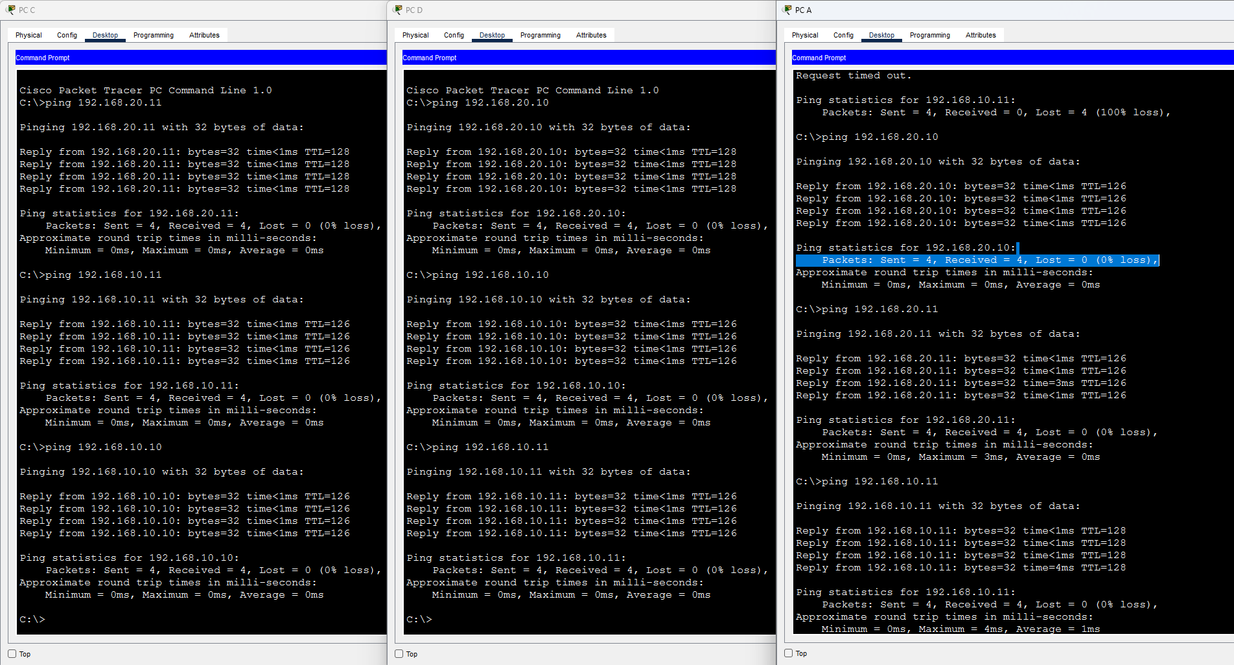
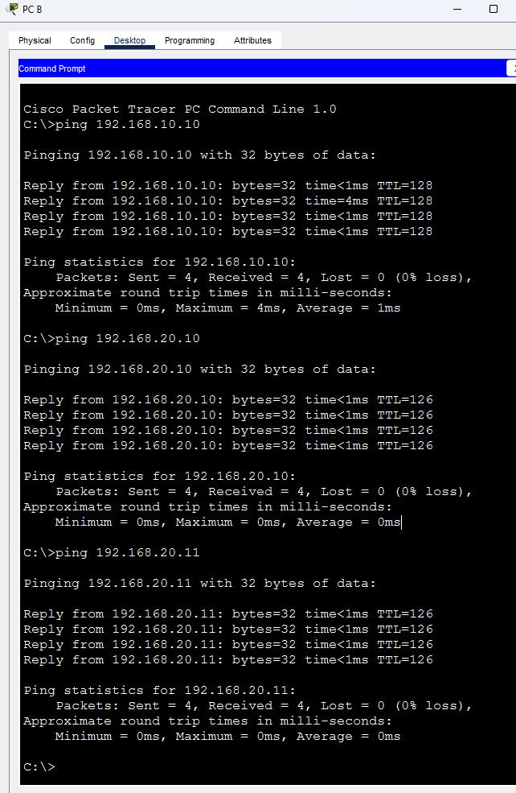

ICMP packet flow analysis
Cisco Packet Tracer Simulation Mode was used to observe an ICMP Echo Request from PC A (192.168.10.10) to PC D (192.168.20.11).
Observed request path:
PC A -> SW1 -> R1 -> R2 -> SW2 -> PC D
PC A determined that the destination was outside its local subnet and sent the packet to its default gateway, R1.
SW1 forwarded the Ethernet frame based on its destination MAC address.
R1 examined the destination IP address and used its static route to forward the packet toward R2 through GigabitEthernet0/0.
R2 identified the destination network as directly connected and forwarded the packet through GigabitEthernet0/1 toward SW2 and PC D.
PC D generated an ICMP Echo Reply that followed the reverse path back to PC A.
Observed reply path:
PC D -> SW2 -> R2 -> R1 -> SW1 -> PC A
The simulation demonstrated that routers make forwarding decisions using IP addresses and routing tables, while switches forward Ethernet frames using MAC addresses.
At each routed Ethernet hop, a new Ethernet frame is created with the appropriate source and destination MAC addresses. The original source and destination IP addresses remain unchanged in this lab.
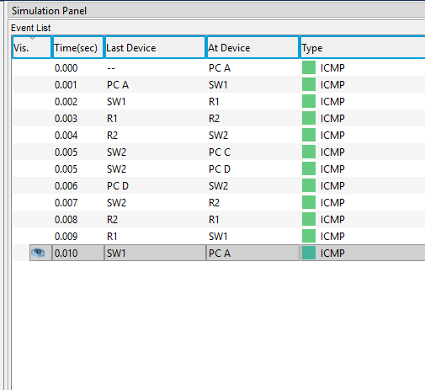
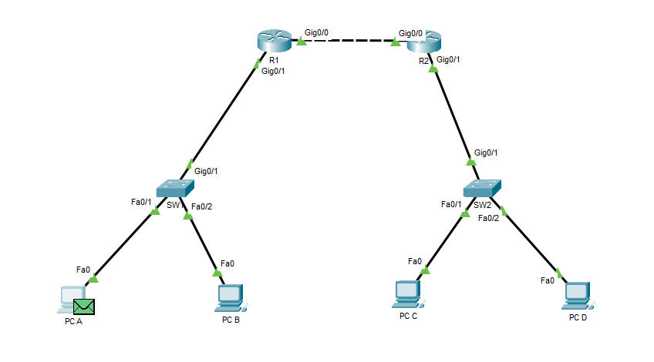
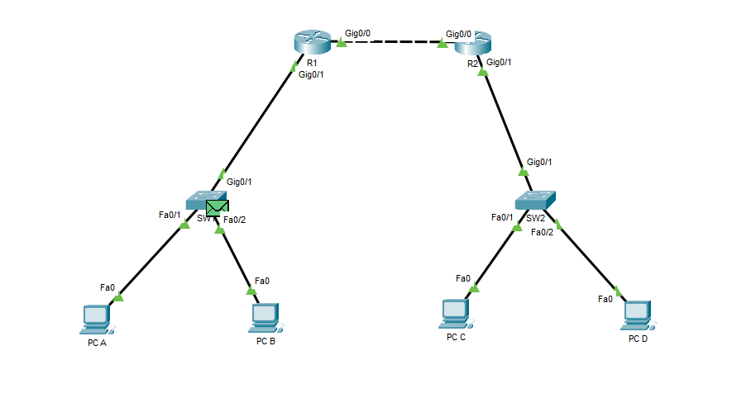
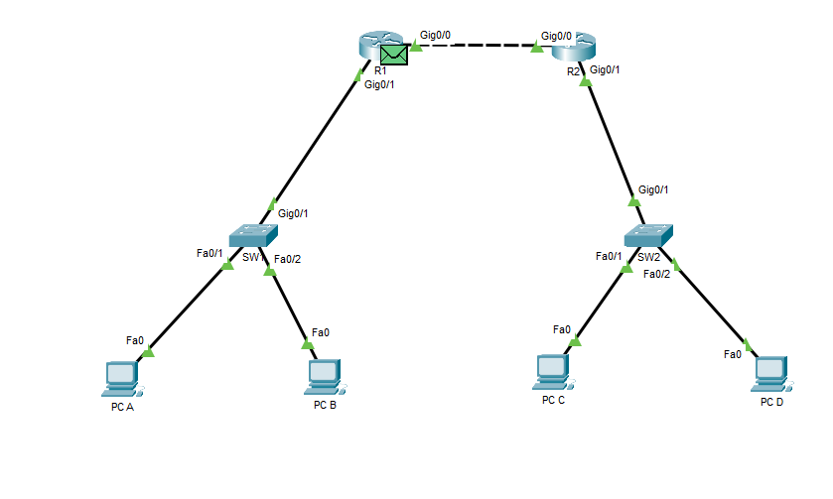
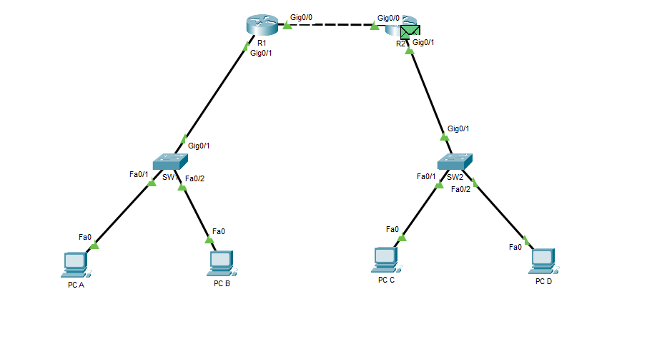
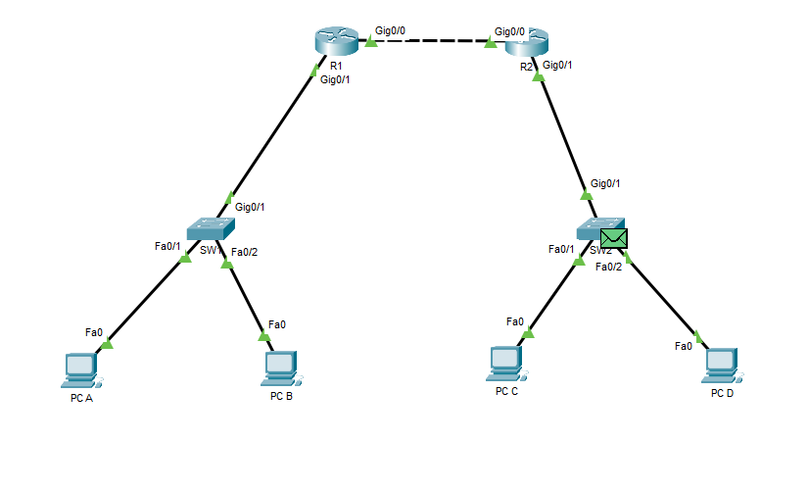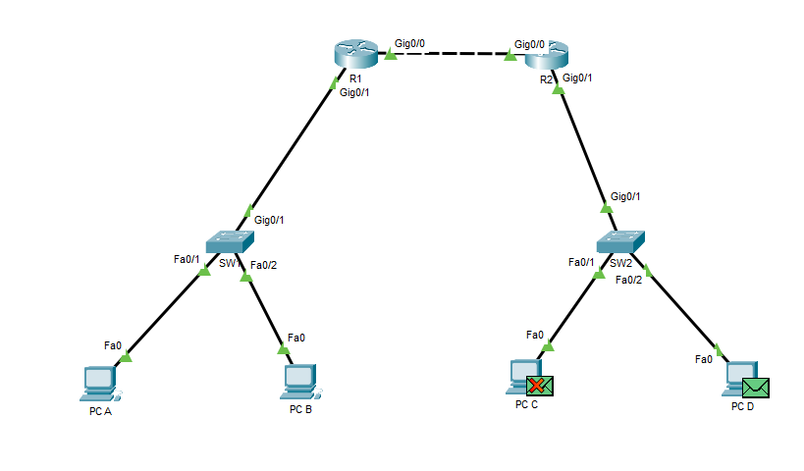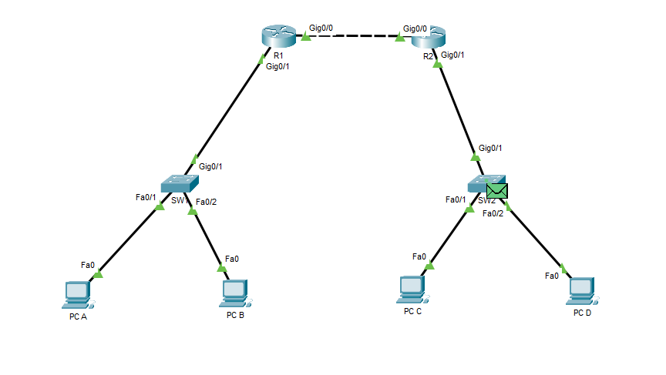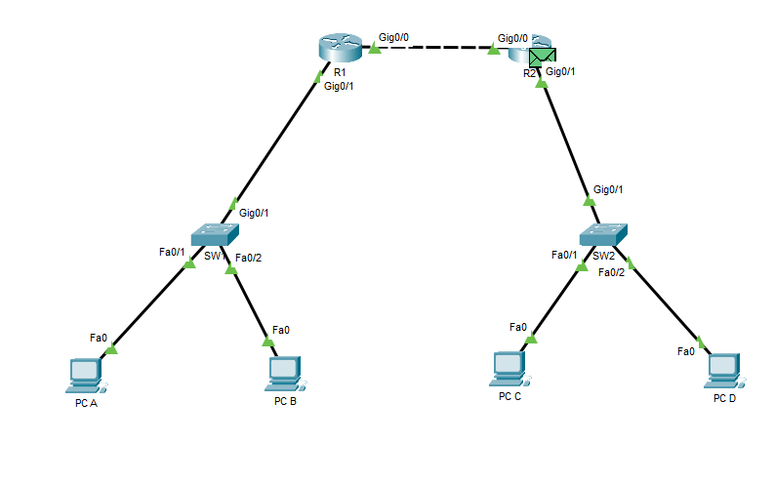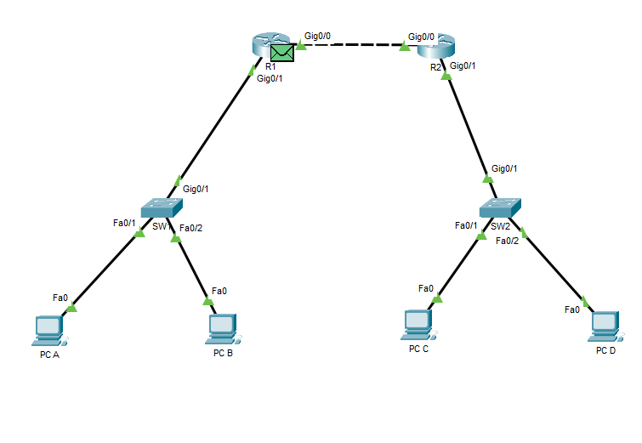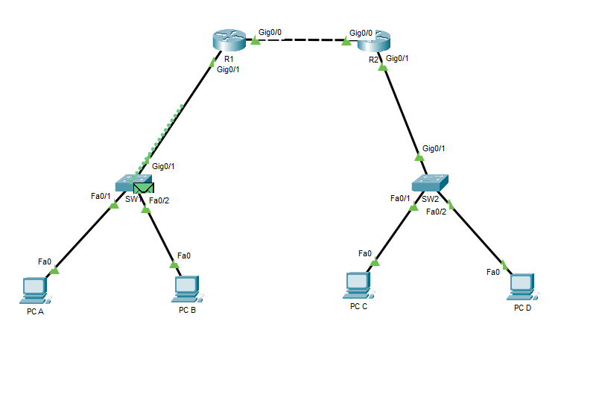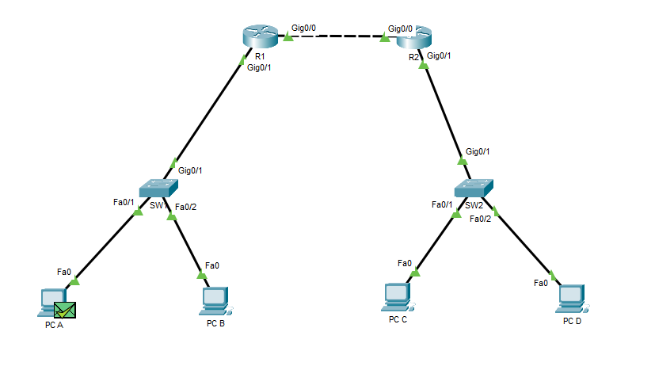

Network Device Responsibilities
End Hosts
PCs are end devices that originate and receive network communications. Depending on the applications running, they may act as clients, servers, or both.
In this lab, PC A generated an ICMP Echo Request and PC D responded with an Echo Reply.
Switches
Switches connect devices within a LAN and forward Ethernet frames using MAC addresses.
They learn MAC addresses by examining the source MAC address of incoming frames and associating those addresses with switch ports.
When a destination MAC address is unknown, the switch floods the frame through the other forwarding ports within the same VLAN.
Routers
Routers connect different IP networks and forward packets based on destination IP addresses and routing-table information.
In this lab, R1 and R2 used static routes to exchange traffic between the two LANs.
Routers also separate Layer 2 broadcast domains.

